+ Seventh Sunday after the Epiphany +

February 20, Year of our Lord 2022 | DS3

+ Confession and Absolution +

Hymn of Invocation: 814 O Bless the Lord, My Soul
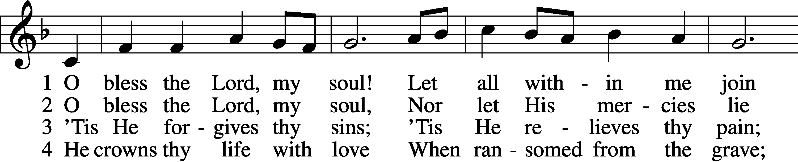
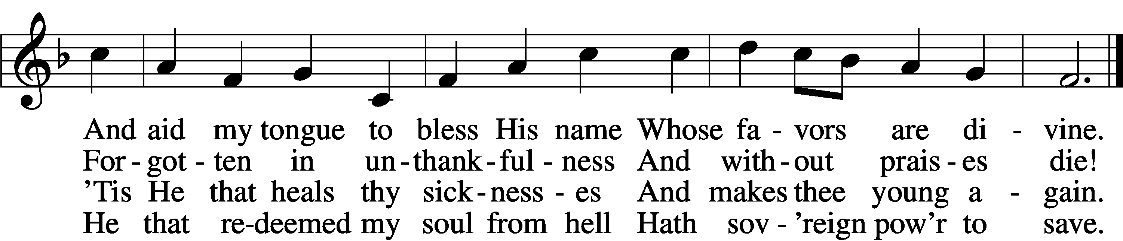

5 He fills the poor with good; He gives the suff’rers rest.
The Lord hath judgments for the proud And justice for th’oppressed.

6 His wondrous works and ways He made by Moses known,
But sent the world His truth and grace By His belovèd Son.
Text and tune: Public domain

The sign of the cross may be made by all in remembrance of their Baptism.

Invocation Matthew 28:19b; 18:20
P In the name of the Father and of the T Son and of the Holy Spirit. C Amen.

Exhortation Hebrews 10:22; Psalm 124:8; Psalm 32:5
P Beloved in the Lord! Let us draw near with a true heart and confess our sins unto God our Father, beseeching Him in the name of our Lord Jesus Christ to grant us forgiveness.
P Our help is in the name of the Lord,
C who made heaven and earth.
P I said, I will confess my transgressions unto the Lord,
C and You forgave the iniquity of my sin.

Silence for reflection on God’s Word and for self-examination.

Confession of Sins
P O almighty God, merciful Father,
C I, a poor, miserable sinner, confess unto You all my sins and iniquities with which I have ever offended You and justly deserved Your temporal and eternal punishment. But I am heartily sorry for them and sincerely repent of them, and I pray You of Your boundless mercy and for the sake of the holy, innocent, bitter sufferings and death of Your beloved Son, Jesus Christ, to be gracious and merciful to me, a poor, sinful being.

Absolution [John 20:19–23]
P Upon this your confession, I, by virtue of my office, as a called and ordained servant of the Word, announce the grace of God unto all of you, and in the stead and by the command of my Lord Jesus Christ I forgive you all your sins in the name of the Father and of the T Son and of the Holy Spirit. C Amen.

+ Service of the Word +
Introit Psalm 37:1–5; antiphon: vv. 7a, b
Be still before the Lord and wait patiently | for him;*
fret not yourself over the one who prospers | in his way.
Fret not yourself because of evil- | doers;*
be not envious of wrong- | doers!
For they will soon fade | like the grass*
and wither like the | green herb.
Trust in the Lord, | and do good;*
dwell in the land and befriend | faithfulness.
Delight yourself | in the Lord,*
and he will give you the desires | of your heart.
Commit your way | to the Lord;*
trust in him, and | he will act.
Glory be to the Father and | to the Son*
and to the Holy | Spirit;
as it was in the be- | ginning,*
is now, and will be forever. | Amen.
Be still before the Lord and wait patiently | for him;*
fret not yourself over the one who prospers | in his way.

Kyrie Mark 10:47
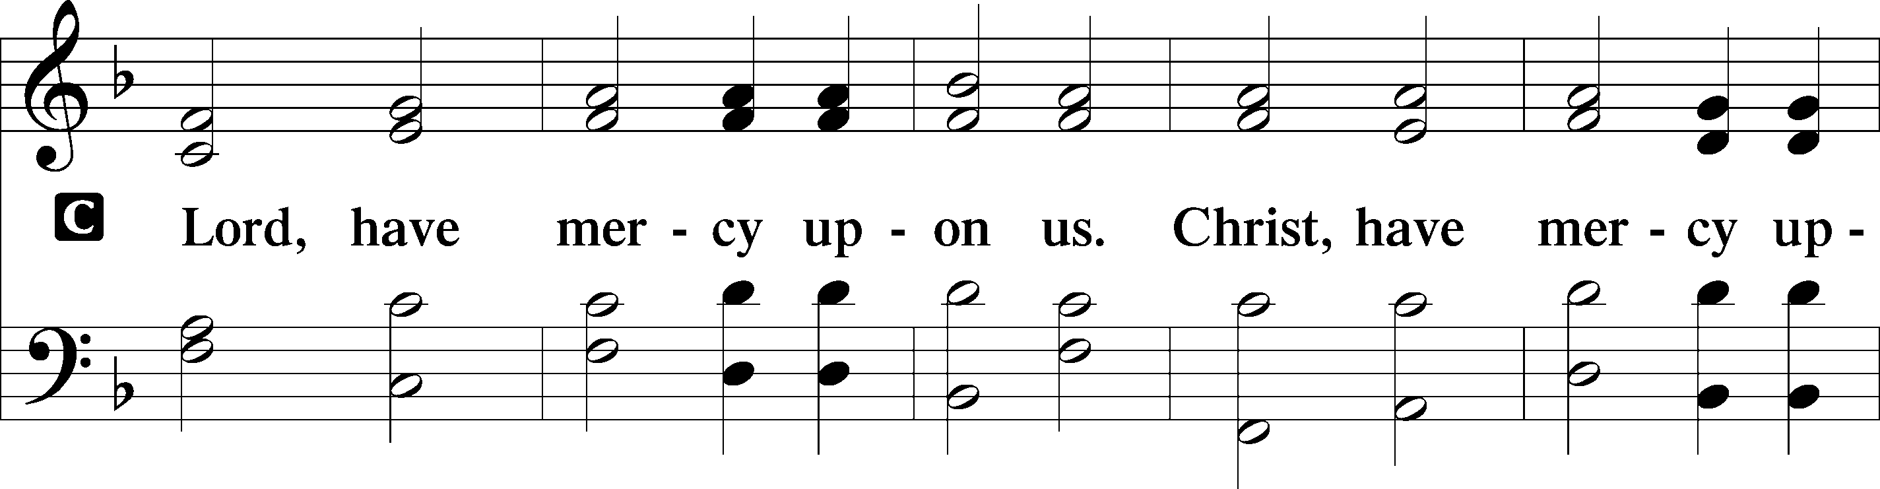
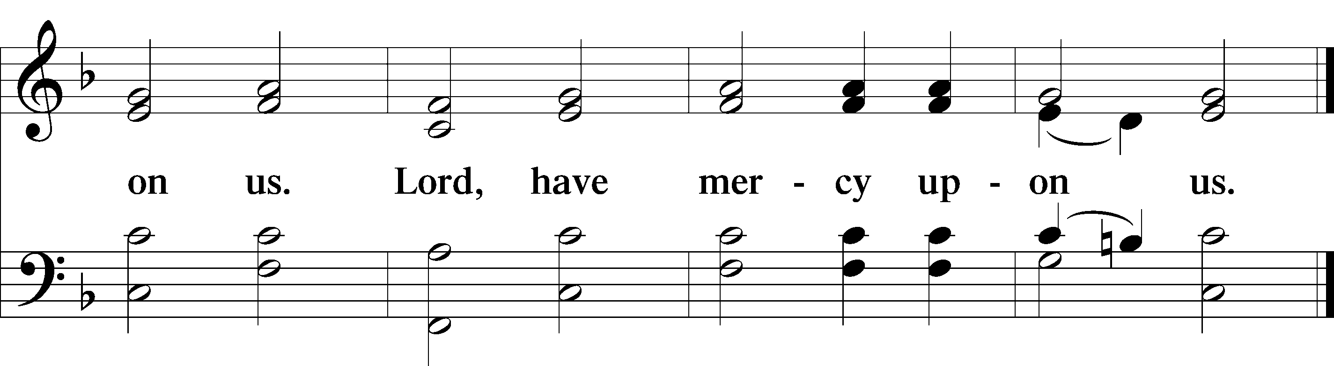

Gloria in Excelsis Luke 2:14; John 1:29
P Glory be to God on high:
C and on earth peace, goodwill toward men.
We praise Thee, we bless Thee, we worship Thee,
we glorify Thee, we give thanks to Thee, for Thy great glory.
O Lord God, heav’nly King, God the Father Almighty.
O Lord, the only-begotten Son, Jesus Christ;
O Lord God, Lamb of God, Son of the Father,
that takest away the sin of the world, have mercy upon us.
Thou that takest away the sin of the world, receive our prayer.
Thou that sittest at the right hand of God the Father, have mercy upon us.
For Thou only art holy; Thou only art the Lord.
Thou only, O Christ, with the Holy Ghost,
art most high in the glory of God the Father. Amen.

Salutation and Collect of the Day
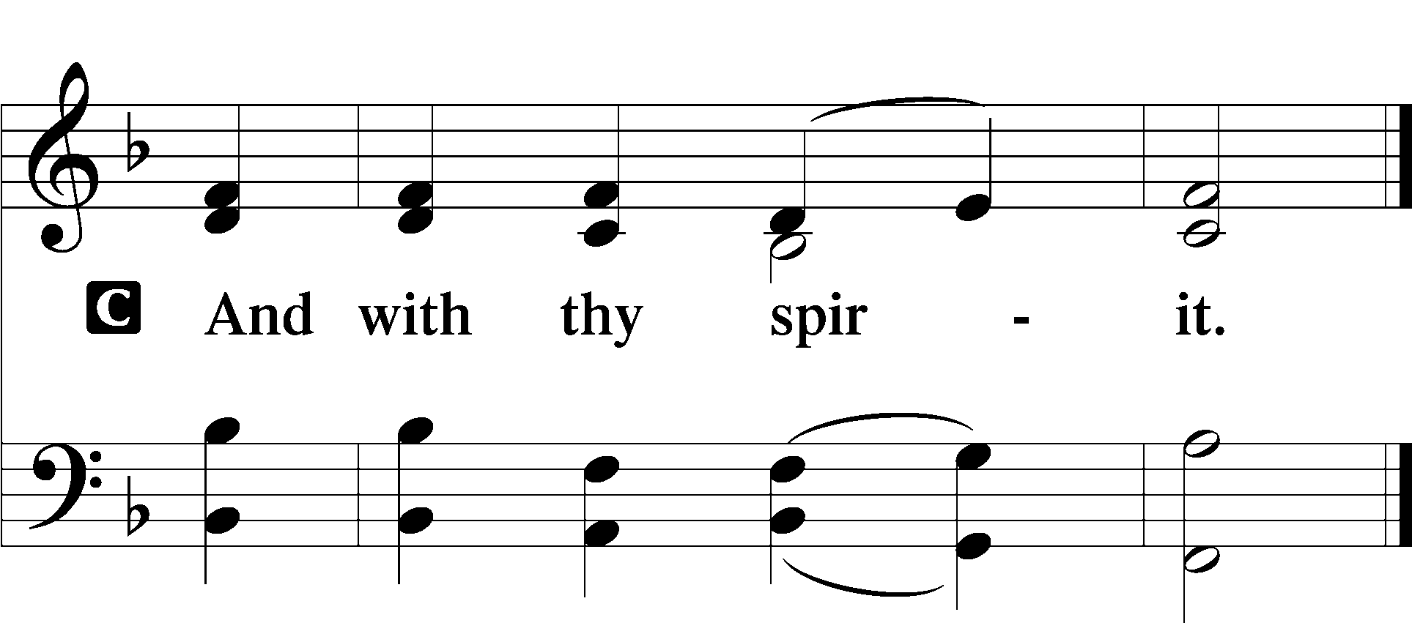
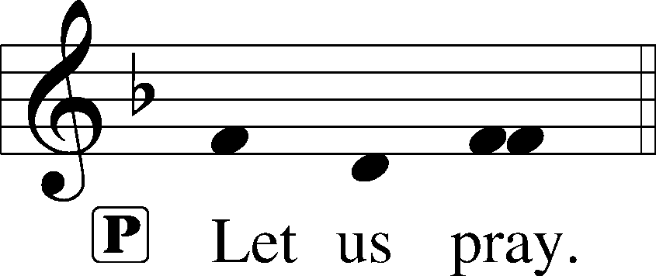

P O God, the strength of all who put their trust in You, mercifully grant that by Your power we may be defended against all adversity; through Jesus Christ, Your Son, our Lord, who lives and reigns with You and the Holy Spirit, one God, now and forever.

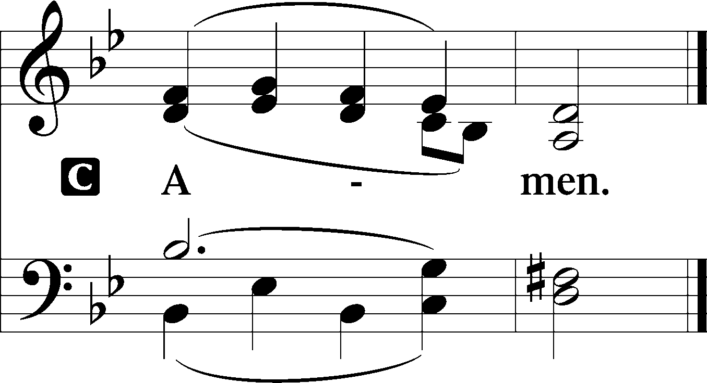

Old Testament Reading Genesis 45:3–15
Joseph said to his brothers, “I am Joseph! Is my father still alive?” But his brothers could not answer him, for they were dismayed at his presence.
So Joseph said to his brothers, “Come near to me, please.” And they came near. And he said, “I am your brother, Joseph, whom you sold into Egypt. And now do not be distressed or angry with yourselves because you sold me here, for God sent me before you to preserve life. For the famine has been in the land these two years, and there are yet five years in which there will be neither plowing nor harvest. And God sent me before you to preserve for you a remnant on earth, and to keep alive for you many survivors. So it was not you who sent me here, but God. He has made me a father to Pharaoh, and lord of all his house and ruler over all the land of Egypt. Hurry and go up to my father and say to him, ‘Thus says your son Joseph, God has made me lord of all Egypt. Come down to me; do not tarry. You shall dwell in the land of Goshen, and you shall be near me, you and your children and your children’s children, and your flocks, your herds, and all that you have. There I will provide for you, for there are yet five years of famine to come, so that you and your household, and all that you have, do not come to poverty.’ And now your eyes see, and the eyes of my brother Benjamin see, that it is my mouth that speaks to you. You must tell my father of all my honor in Egypt, and of all that you have seen. Hurry and bring my father down here.” Then he fell upon his brother Benjamin’s neck and wept, and Benjamin wept upon his neck. And he kissed all his brothers and wept upon them. After that his brothers talked with him.

A This is the Word of the Lord. C Thanks be to God.

Gradual Psalm 117:1–2a; 96:8
C Praise the Lord, all nations!
Extol him, all peoples!
For great is his steadfast love toward us,
and the faithfulness of the Lord endures forever.
Ascribe to the Lord the glory due his name;
bring an offering, and come into his courts!

Epistle 1 Corinthians 15:21–26, 30–42
For as by a man came death, by a man has come also the resurrection of the dead. For as in Adam all die, so also in Christ shall all be made alive. But each in his own order: Christ the firstfruits, then at his coming those who belong to Christ. Then comes the end, when he delivers the kingdom to God the Father after destroying every rule and every authority and power. For he must reign until he has put all his enemies under his feet. The last enemy to be destroyed is death. . . .
Why am I in danger every hour? I protest, brothers, by my pride in you, which I have in Christ Jesus our Lord, I die every day! What do I gain if, humanly speaking, I fought with beasts at Ephesus? If the dead are not raised, “Let us eat and drink, for tomorrow we die.” Do not be deceived: “Bad company ruins good morals.” Wake up from your drunken stupor, as is right, and do not go on sinning. For some have no knowledge of God. I say this to your shame.
But someone will ask, “How are the dead raised? With what kind of body do they come?” You foolish person! What you sow does not come to life unless it dies. And what you sow is not the body that is to be, but a bare kernel, perhaps of wheat or of some other grain. But God gives it a body as he has chosen, and to each kind of seed its own body. For not all flesh is the same, but there is one kind for humans, another for animals, another for birds, and another for fish. There are heavenly bodies and earthly bodies, but the glory of the heavenly is of one kind, and the glory of the earthly is of another. There is one glory of the sun, and another glory of the moon, and another glory of the stars; for star differs from star in glory.
So is it with the resurrection of the dead. What is sown is perishable; what is raised is imperishable.

A This is the Word of the Lord. C Thanks be to God.
Verse of the Day Luke 6:36
P Alleluia. Be merciful, even as your Father is merciful. Alleluia.

Triple Alleluia
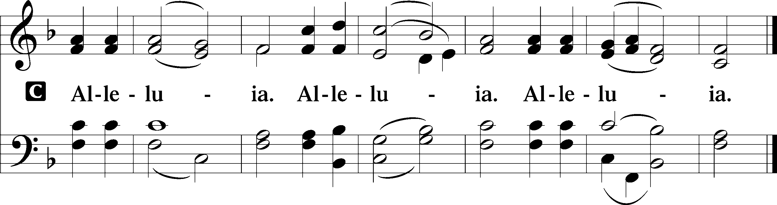

Holy Gospel Luke 6:27–38
P The Holy Gospel according to St. Luke, the sixth chapter.

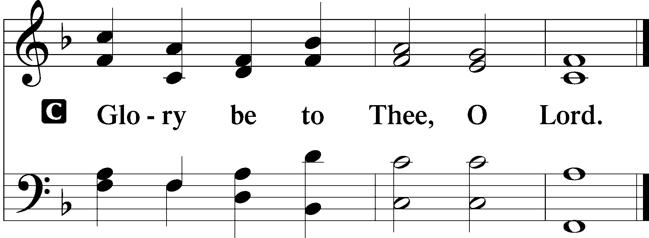

[Jesus said:] “But I say to you who hear, Love your enemies, do good to those who hate you, bless those who curse you, pray for those who abuse you. To one who strikes you on the cheek, offer the other also, and from one who takes away your cloak do not withhold your tunic either. Give to everyone who begs from you, and from one who takes away your goods do not demand them back. And as you wish that others would do to you, do so to them.
“If you love those who love you, what benefit is that to you? For even sinners love those who love them. And if you do good to those who do good to you, what benefit is that to you? For even sinners do the same. And if you lend to those from whom you expect to receive, what credit is that to you? Even sinners lend to sinners, to get back the same amount. But love your enemies, and do good, and lend, expecting nothing in return, and your reward will be great, and you will be sons of the Most High, for he is kind to the ungrateful and the evil. Be merciful, even as your Father is merciful.
“Judge not, and you will not be judged; condemn not, and you will not be condemned; forgive, and you will be forgiven; give, and it will be given to you. Good measure, pressed down, shaken together, running over, will be put into your lap. For with the measure you use it will be measured back to you.”

P This is the Gospel of the Lord.
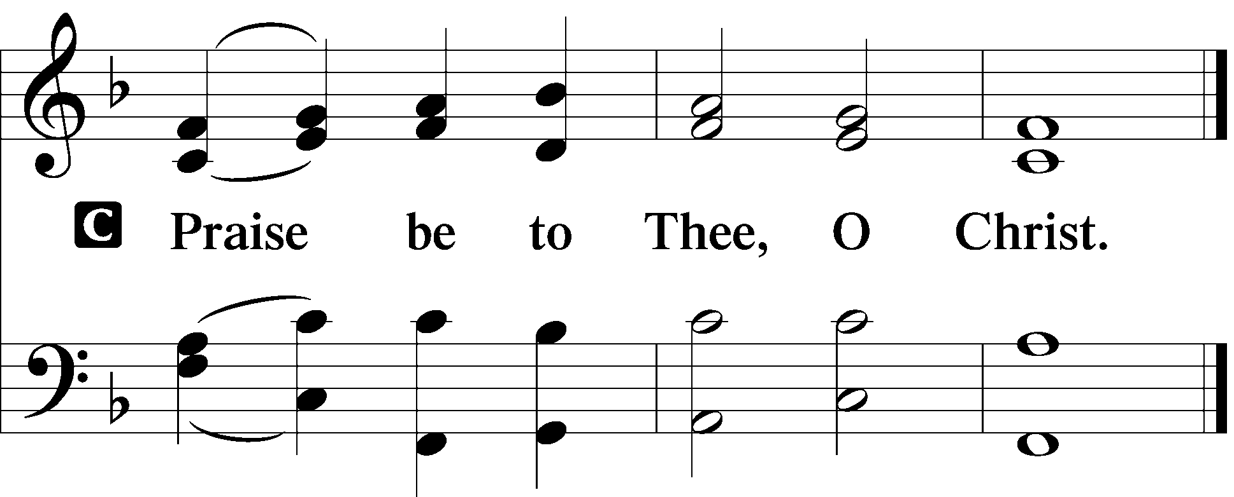

Nicene Creed
C I believe in one God, the Father Almighty, maker of heaven and earth and of all things visible and invisible. And in one Lord Jesus Christ the only-begotten Son of God, begotten of His Father before all worlds, God of God, Light of Light, very God of very God, begotten, not made, being of one substance with the Father, by whom all things were made; who for us men and for our salvation came down from heaven and was incarnate by the Holy Spirit of the virgin Mary and was made man; and was crucified also for us under Pontius Pilate. He suffered and was buried. And the third day He rose again according to the Scriptures and ascended into heaven and sits at the right hand of the Father. And He will come again with glory to judge both the living and the dead, whose kingdom will have no end. And I believe in the Holy Spirit, the Lord and giver of life, who proceeds from the Father and the Son, who with the Father and the Son together is worshiped and glorified, who spoke by the prophets. And I believe in one holy Christian and apostolic Church, I acknowledge one Baptism for the remission of sins, and I look for the resurrection of the dead and the life T of the world to come. Amen.

Hymn of the Day: 834 O God, O Lord of Heaven and Earth
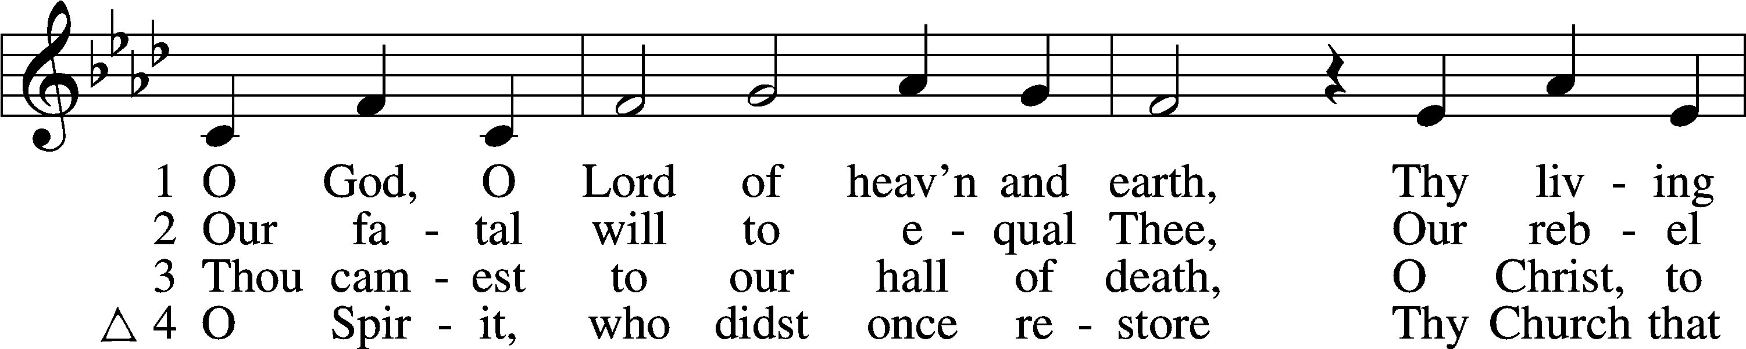
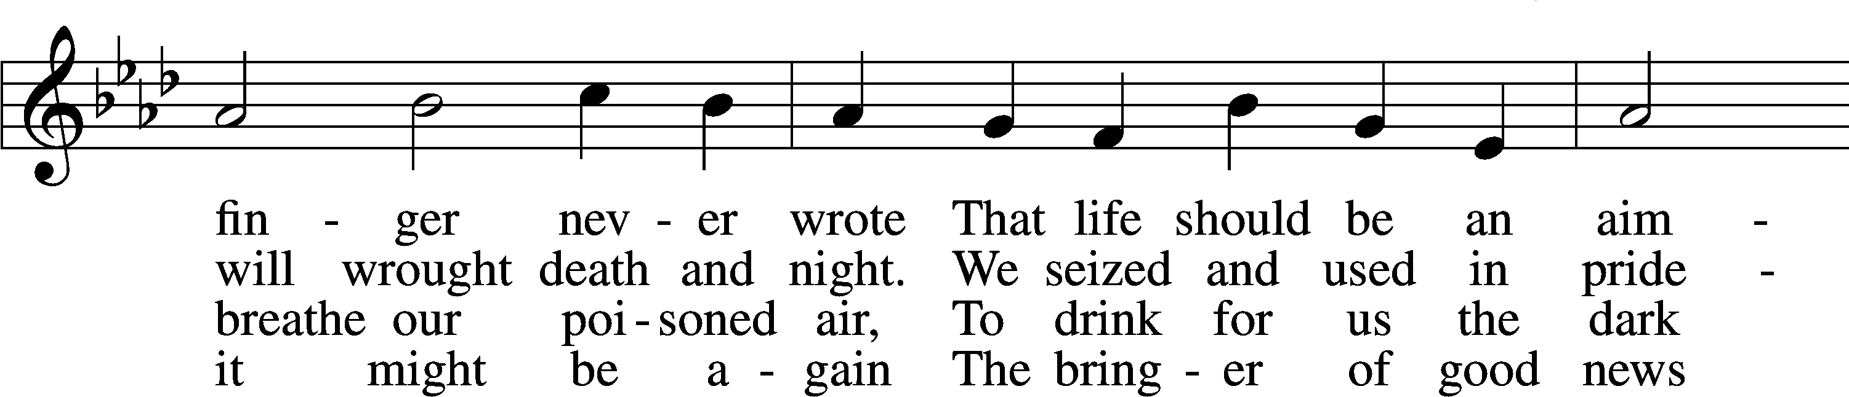
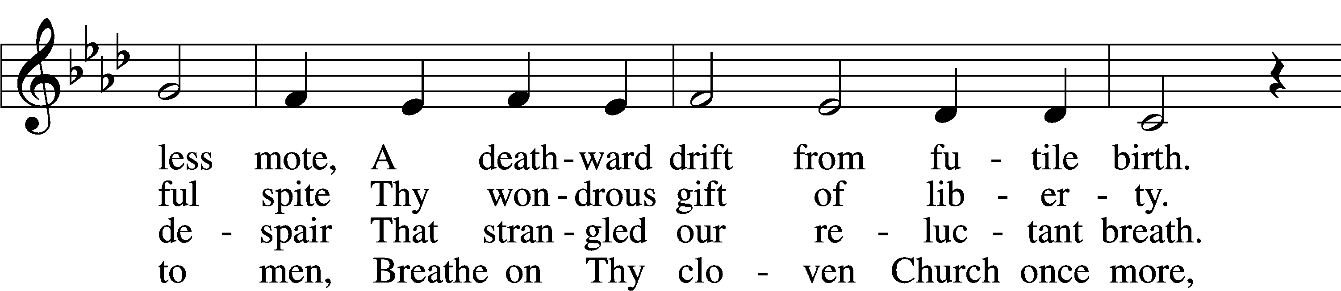
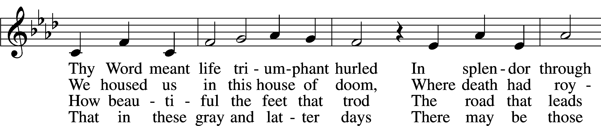
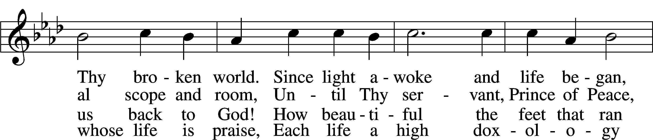
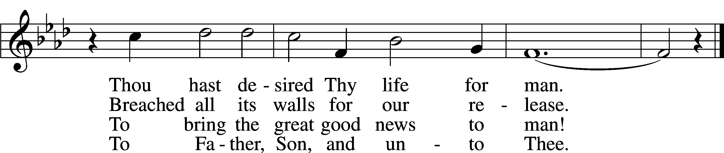
Text and tune: © 1967 Augsburg Fortress. Used by permission: LSB Hymn License no. 110020024
+ Sermon +

Offertory Psalm 51:10–12
C Create in me a clean heart, O God, and renew a right spirit within me.
Cast me not away from Thy presence, and take not Thy Holy Spirit from me.
Restore unto me the joy of Thy salvation, and uphold me with Thy free spirit. Amen.

Announcement of Offering and Greetings of Peace
The people may greet one another in the name of the Lord, saying, “Peace be with you,” as a sign of reconciliation and of the unity of the Spirit in the bond of peace (Matt. 5:22–24; Eph. 4:1–3).

Prayers to God on Behalf of…
World: Troubled regions of the world. Church: Epiphany celebration and beholding the places in word and world where God was manifest for us.
Expecting a child: Luke & Blair Johnson Recently born: Addilyn Christianson (Gretchen’s niece’s newborn daughter); Grace and Callie (Smolter’s extended family): newborns now home from hospital.

Alex and Shelby Hicks (Praising God for the news of a welcome pregnancy, but then soon after their rejoicing turned to sorrow—now mourning the loss in miscarriage; have named the child Jude).
Mourning: Family of Tamra Kincaid DeHaven (who passed 1/23). Family of Jim Vesper (Jim’s father passed away 1/13-14). Family of LCMS Pastor Don Schmidt of Messiah Lutheran Church in Memphis who died from covid. Family of Joyce (Meghan Collver’s grandmother): who passed away from covid pneumonia. Family of Sherrie Wheat: who passed away from covid pneumonia. Family of Bruce Weirauch (Vicky Gorman’s uncle), especially Robin his wife. Family and friends of Claudette Kinney who passed on 11/23. Family of Imogene Allen who passed on 11/25.

Health: Hope (Rebecca Key’s mother, health); Pastor Jasper in Kenya (recovering after surgery); Larry Wacker (fell and broke pelvis, still in Alaska); Ted Wilson (health). Theresa Lindsay (lung cancer surgery scheduled for 2/28). Aurora’s son Stevie (possible cancer) and granddaughter Erica (emergency heart surgery recovery). Kenna Chorney’s parents: Don & Gail Rieman (health, lingering issues from covid). Marvin (Jim Vesper’s friend) good progress recovering from an auto accident. Dick Mohr (thanksgiving for recovery from covid). Lisa Gift’s sister in Ohio (health). Rayland Greene (Jim Vespers’s friend’s grandson, 3.5 months old—still in the womb, mother’s water broke way too early). Camebre Pearl (Carol Ehren’s granddaughter): facing surgery to correct a rare malformation. Cathy Wacker’s parents: Charlene (hospice), Bill, dementia, health. Anna Roberts (Jim & Maureen’s daughter-in-law—married to Travis) cancer surgery recovery. Christy, Kim Smolter’s cousin, health and mourning. Lee Schuck (broken hip recovery). Pam Truby (upcoming cancer treatments); Larry Wacker (lung condition). Tim Smith health. Pastor Tony Sikora (in Michigan, much recovery needed aftereffects of Covid). Marge Peterson (a friend of Jeanne Lindenfelser) [Marge’s] cousin Sandy who has 30 days of cancer radiation treatments and for Marge’s two greatgrandchildren who both are having seizures. KP Blizzard (newborn great grandson of Sandy Bagley) paralyzed vocal cord. Larry & Janeen Meier (Maureen’s sister and brother-in-law ) health. Carolyn Gaugert (sister-in-law to Sharon Yoder) pancreatic cancer (recent MRI showed no tumors).
Birthdays … Emi Hogan 2/26, Larry L 3/1, Thomas McK 3/4, Teddy L 3/5
Anniversaries … Luke & Blair J 2/22

Lord’s Prayer Matthew 6:9–13
P Lord, remember us in Your kingdom and teach us to pray:
C Our Father who art in heaven,
hallowed be Thy name,
Thy kingdom come,
Thy will be done on earth
as it is in heaven;
give us this day our daily bread;
and forgive us our trespasses
as we forgive those
who trespass against us;
and lead us not into temptation,
but deliver us from evil.
For Thine is the kingdom
and the power and the glory
forever and ever. Amen.

+ Service of the Sacrament +

A Word to Our Guests and Visitors about Communion at Praise
The Lord’s Supper is celebrated at this congregation in the confession and glad confidence that, as He says, our Lord gives into our mouths not only bread and wine but His very Body and Blood to eat and to drink for the forgiveness of sins and to strengthen our union with Him and with one another. Our Lord invites to His table those who trust His words, repent of all sin, and set aside any refusal to forgive and love as He forgives and loves us, that they may show forth His death and resurrection until He comes. Scripture warns that those who come forward to eat and drink our Lord’s Body and Blood in an unworthy manner do so to their great spiritual harm. The Lord’s Supper is also a confession of the faith which is confessed at this altar. Therefore, any who hold a confession differing from that of this congregation and The Lutheran Church—Missouri Synod, and yet to desire to receive the Sacrament (Communion), are encouraged to seek guidance from the pastor.

Preface 2 Timothy 4:22; [Colossians 3:1]; [Psalm 136]
P The Lord be with you.
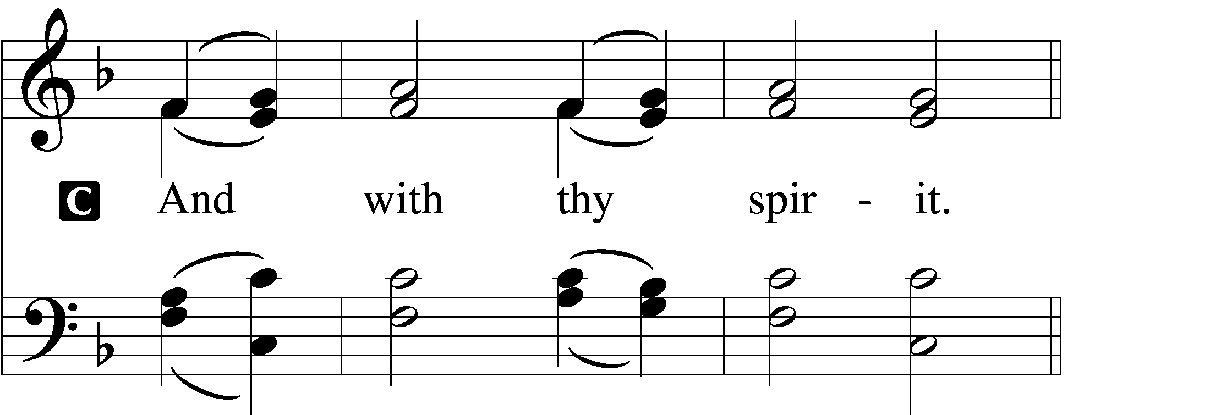

P Lift up your hearts.
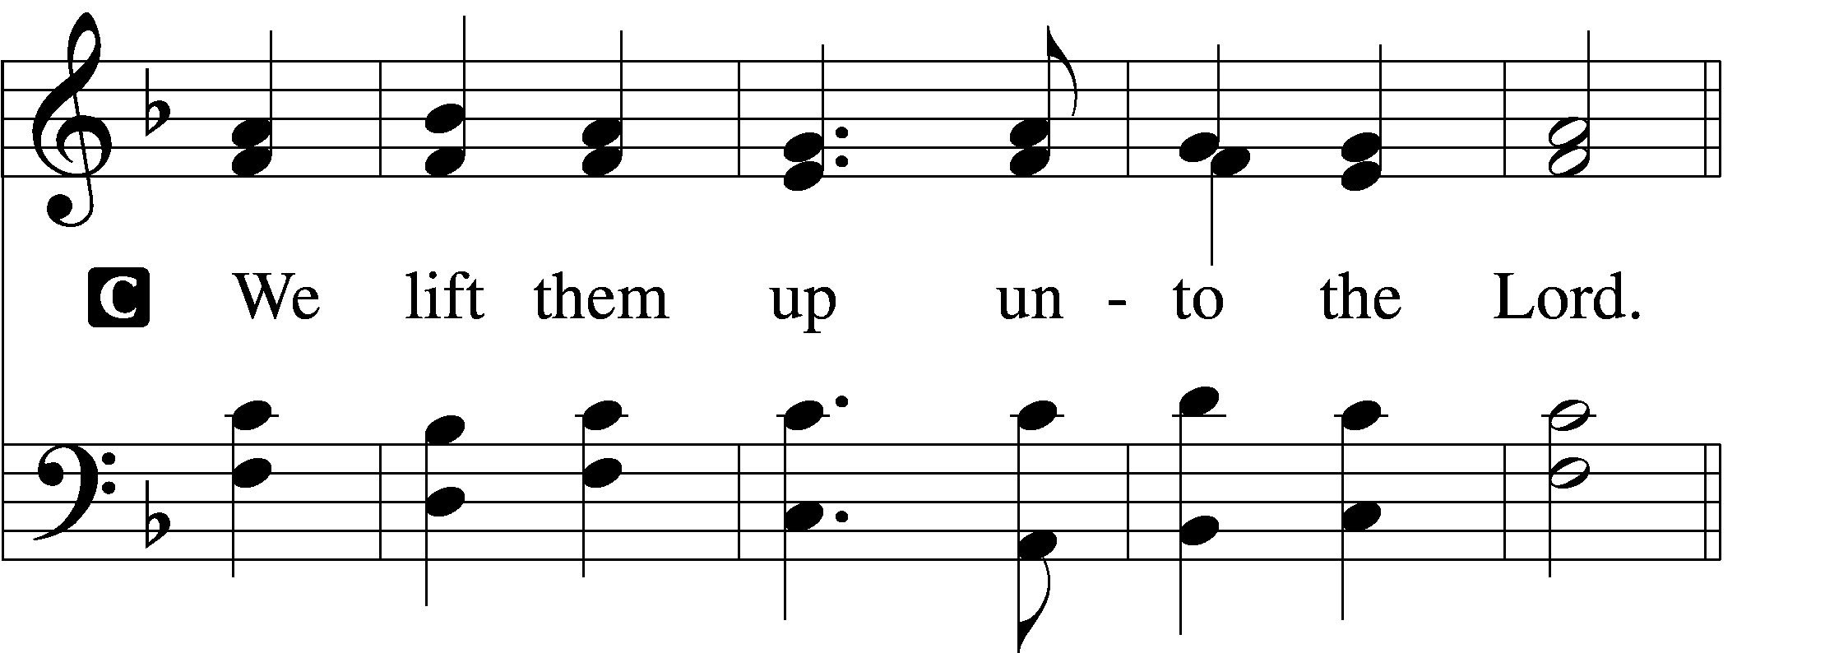

P Let us give thanks unto the Lord, our God.
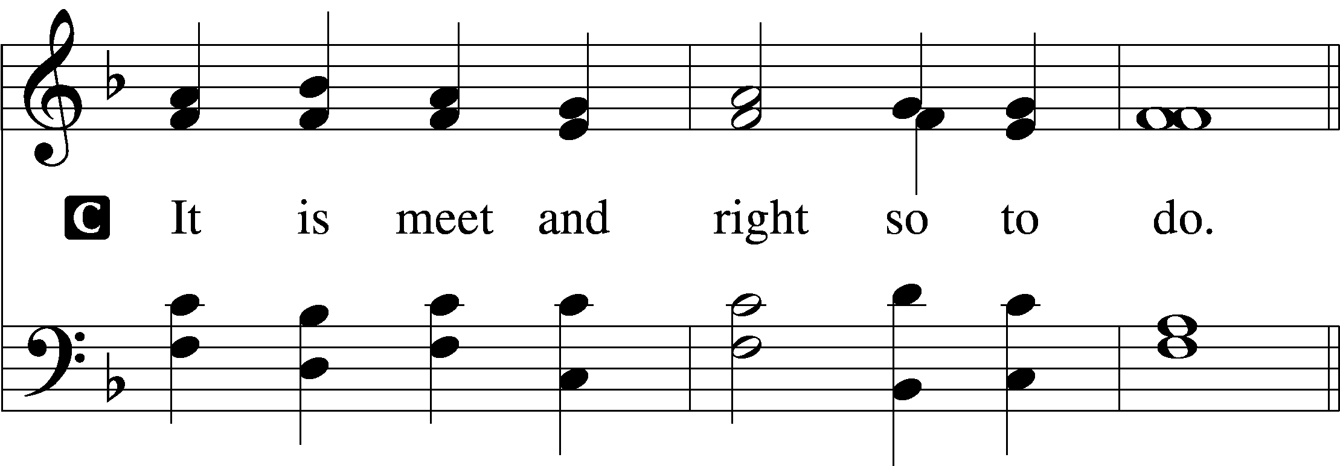

Proper Preface (Abbreviated)
P It is truly meet, right, and salutary . . . evermore praising You and saying:

Sanctus Isaiah 6:3; Matthew 21:9
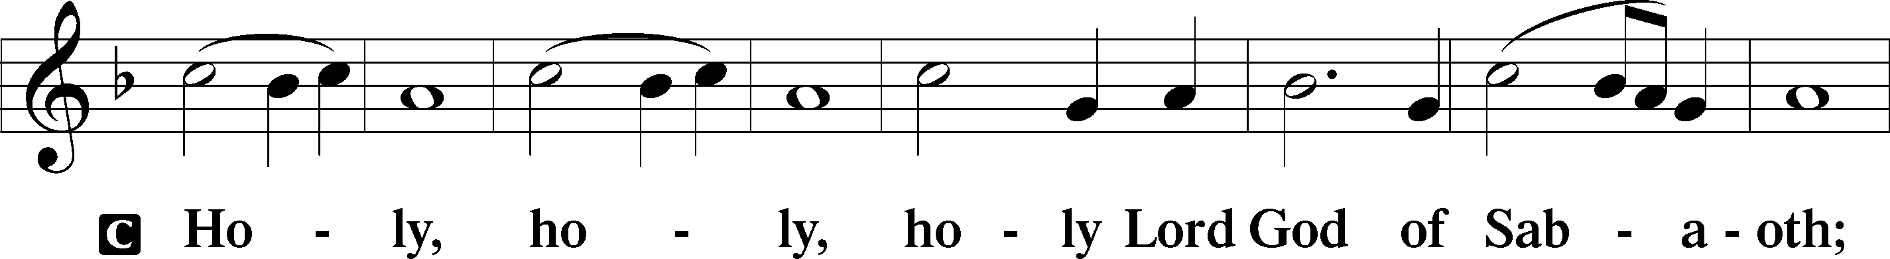
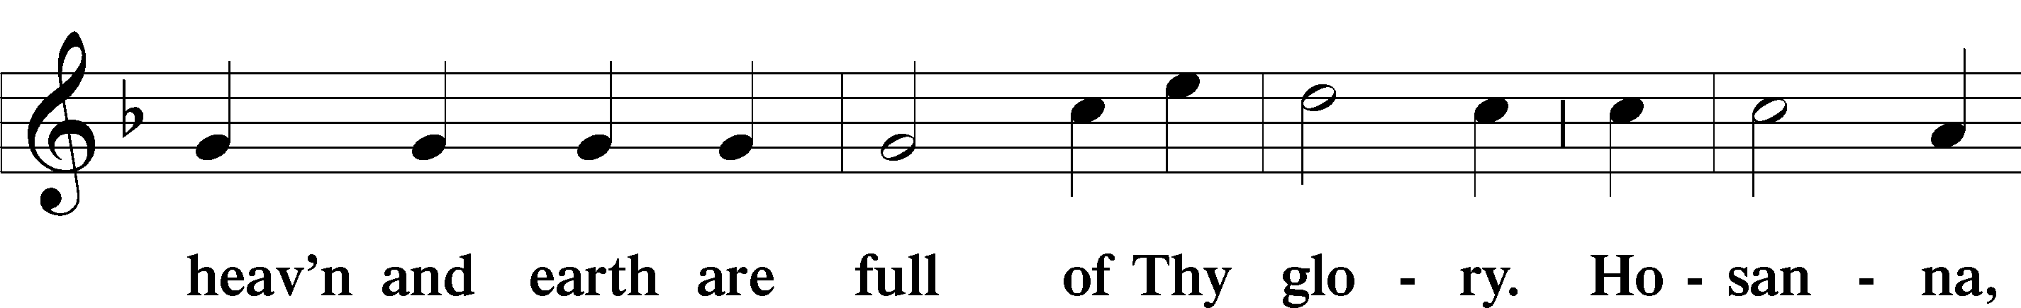
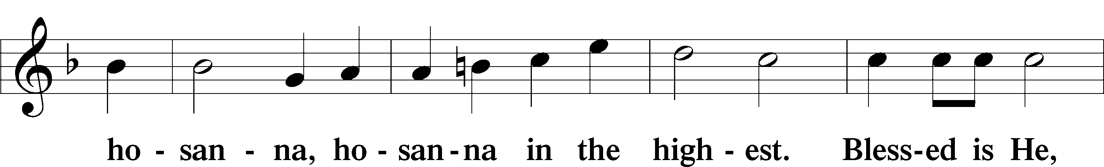
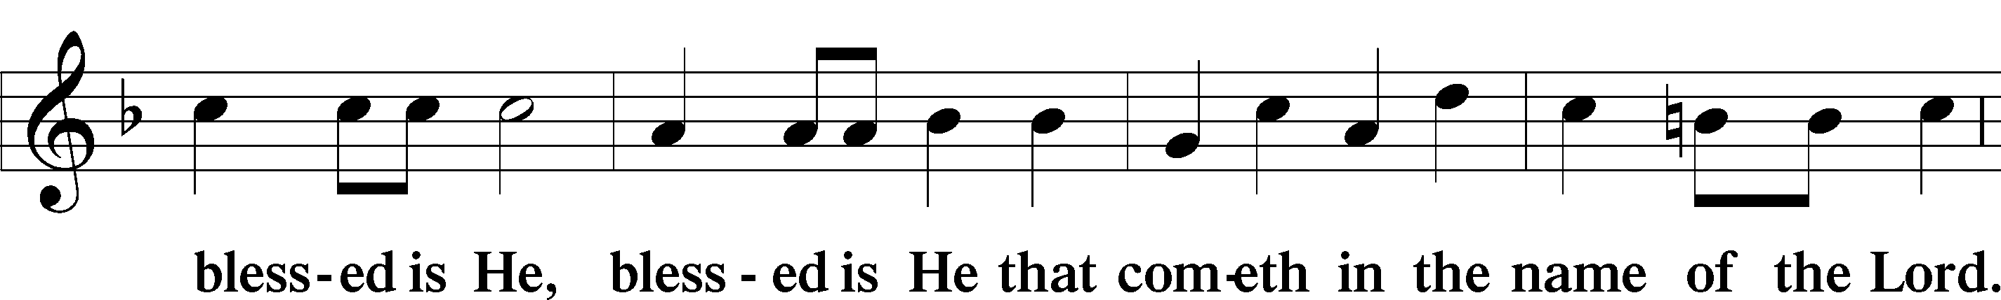
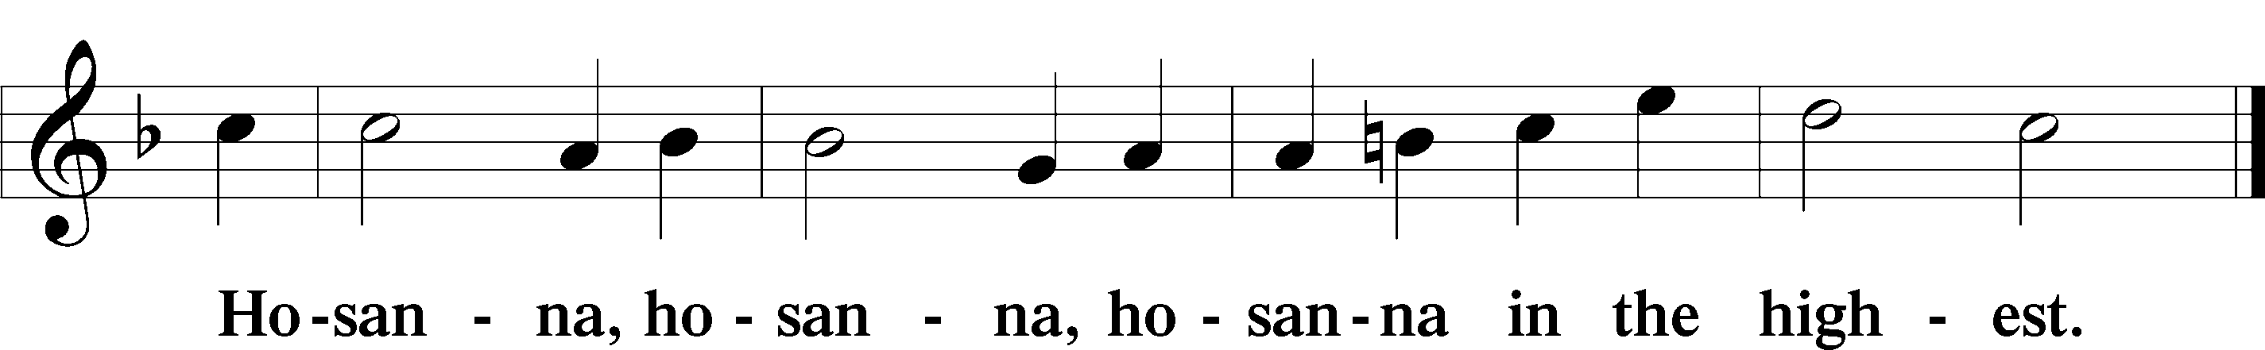

The Words of Our Lord Mt 26:26-30; Mk 14:22-26; Lk 22:14-23; 1 Cor 11:23-25.
P Our Lord Jesus Christ, on the night when He was betrayed, took bread, and when He had given thanks, He broke it and gave it to the disciples and said: “Take, eat; this is My T body, which is given for you. This do in remembrance of Me.”

In the same way also He took the cup after supper, and when He had given thanks, He gave it to them, saying: “Drink of it, all of you; this cup is the new testament in My T blood, which is shed for you for the forgiveness of sins. This do, as often as you drink it, in remembrance of Me.”

Pax Domini John 20:19
P The peace of the Lord be with you always.
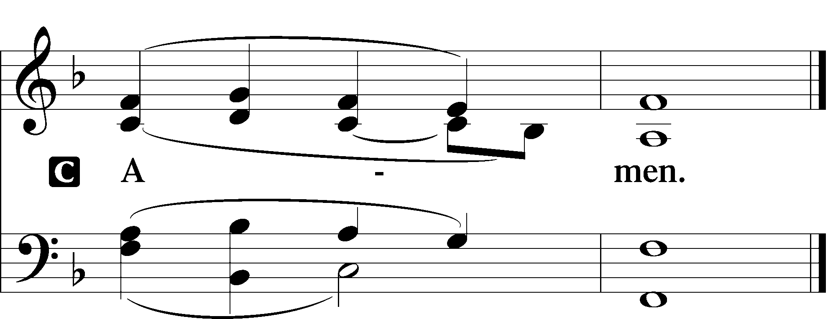

Agnus Dei John 1:29
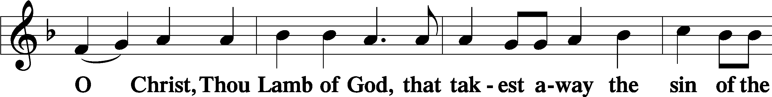
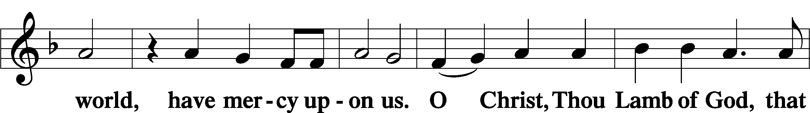
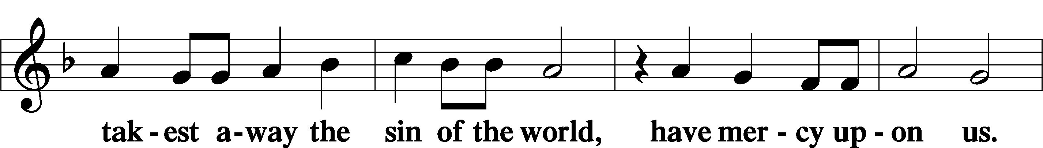
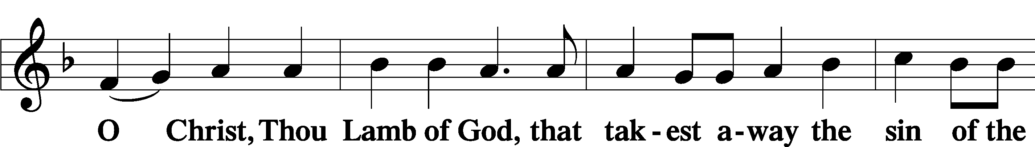

Distribution
Please see our pastor for details about baptism, instruction, and vow of confirmation of our church’s teachings prior to taking the Lord’s Supper (Communion) at Praise.

Distribution Hymn: 628 Your Table I Approach
Distribution Hymn: 692 Praise to You and Adoration
Distribution Hymn: 706 Love in Christ Is Strong and Living
Distribution Hymn: 409 Hail, O Source of Every Blessing

Nunc Dimittis Luke 2:29–32
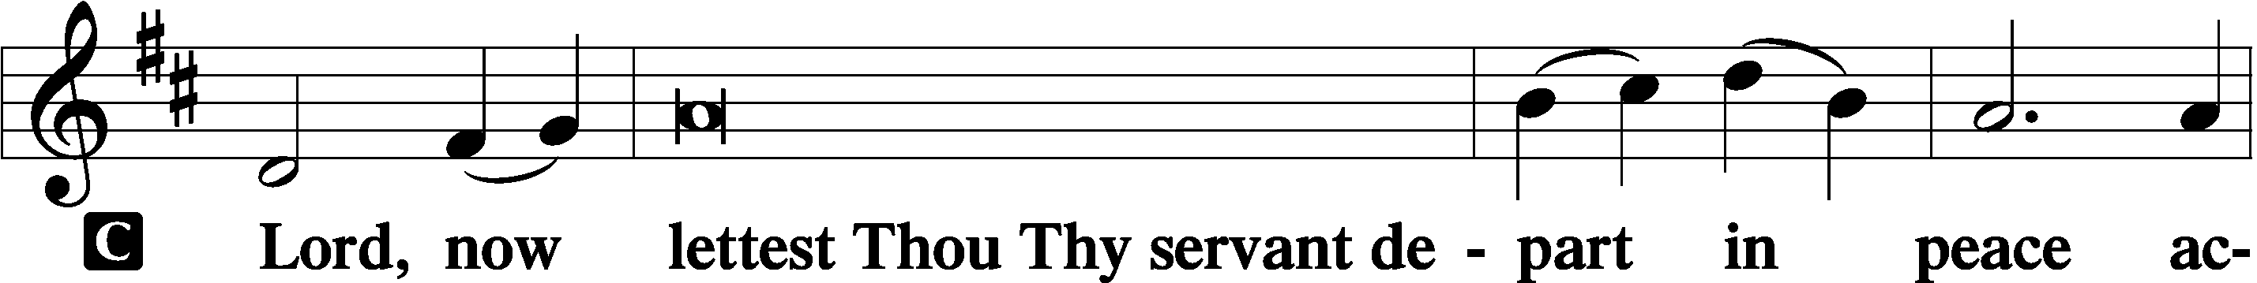
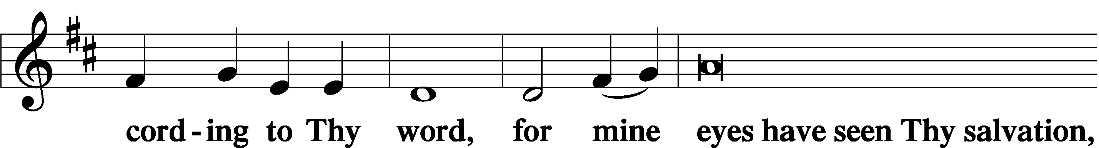
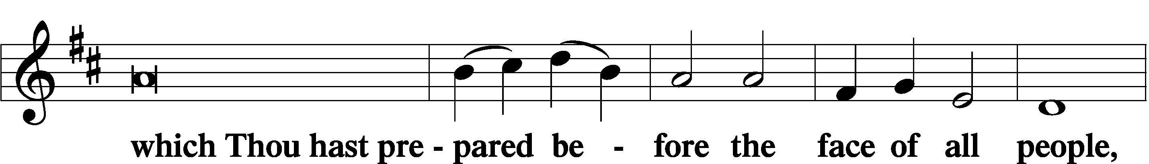
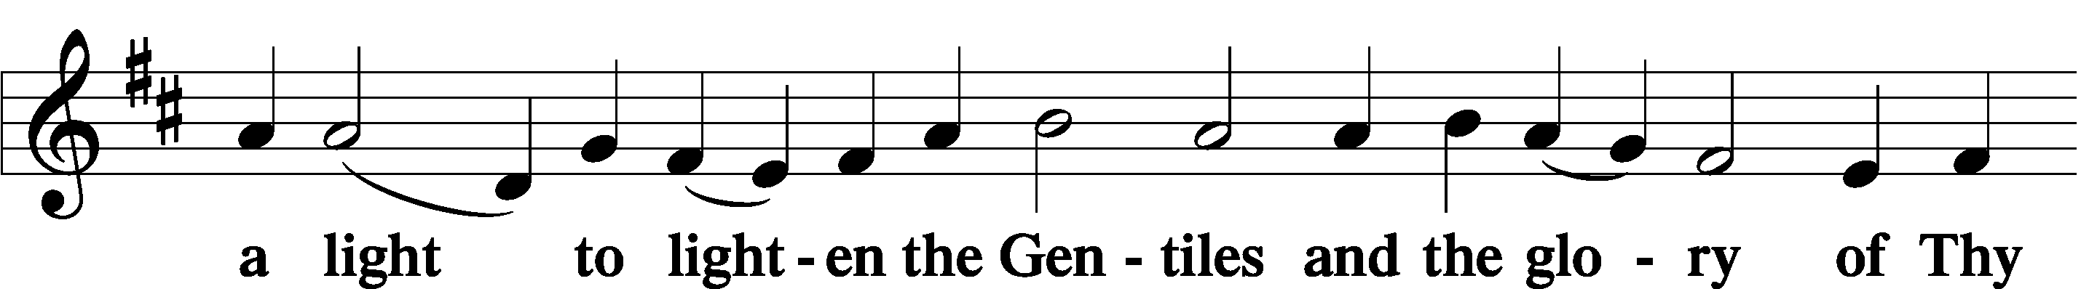
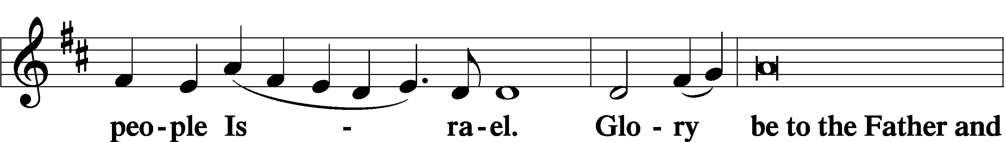
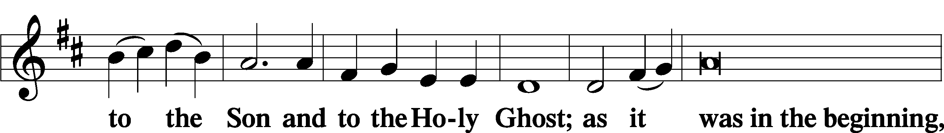
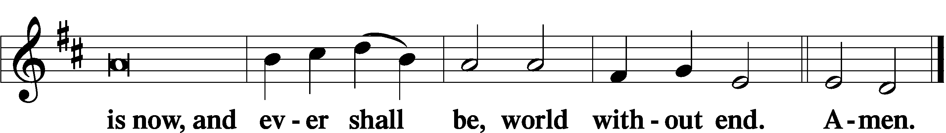

Thanksgiving Psalm 107:1
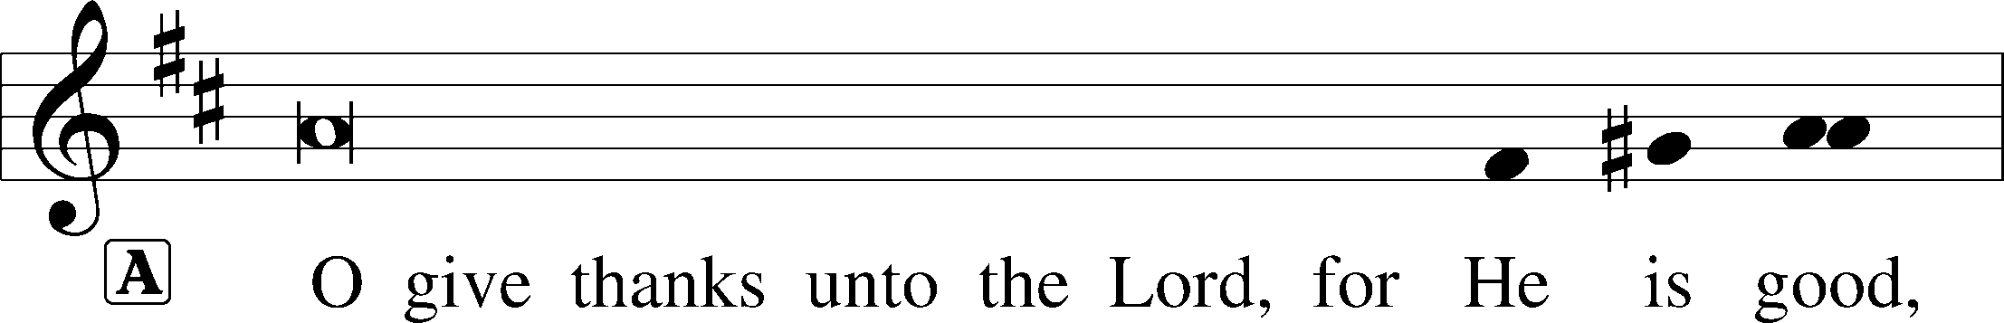
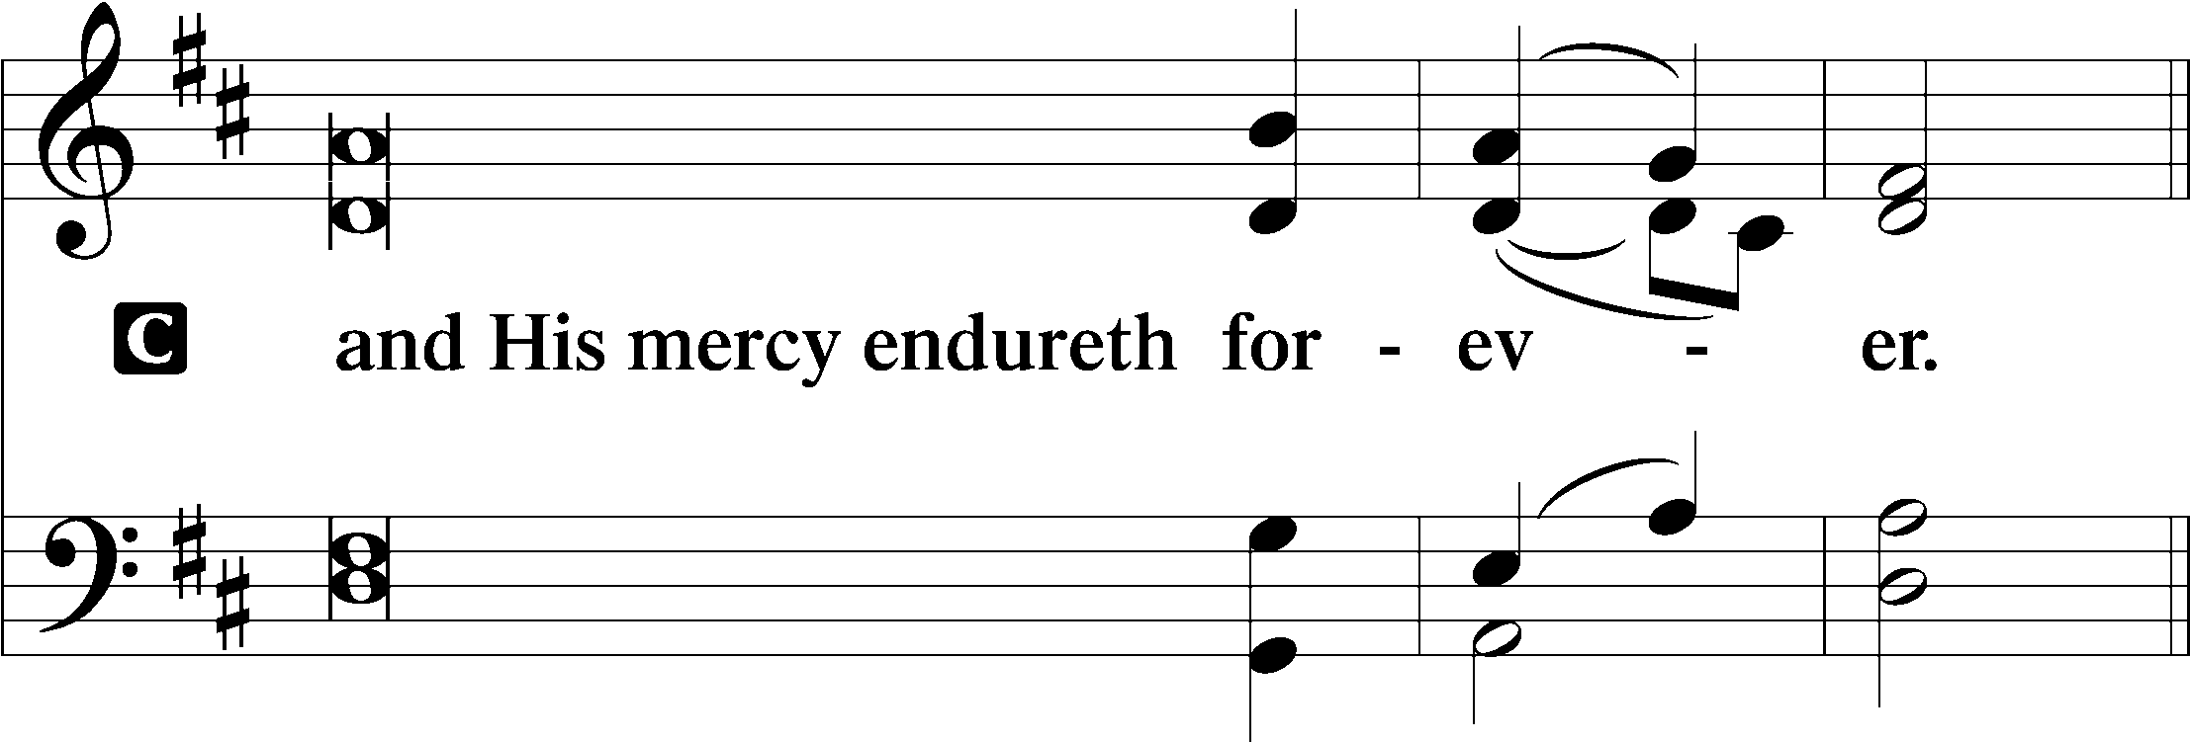
Post-Communion Collect
A Let us pray. … now and forever.

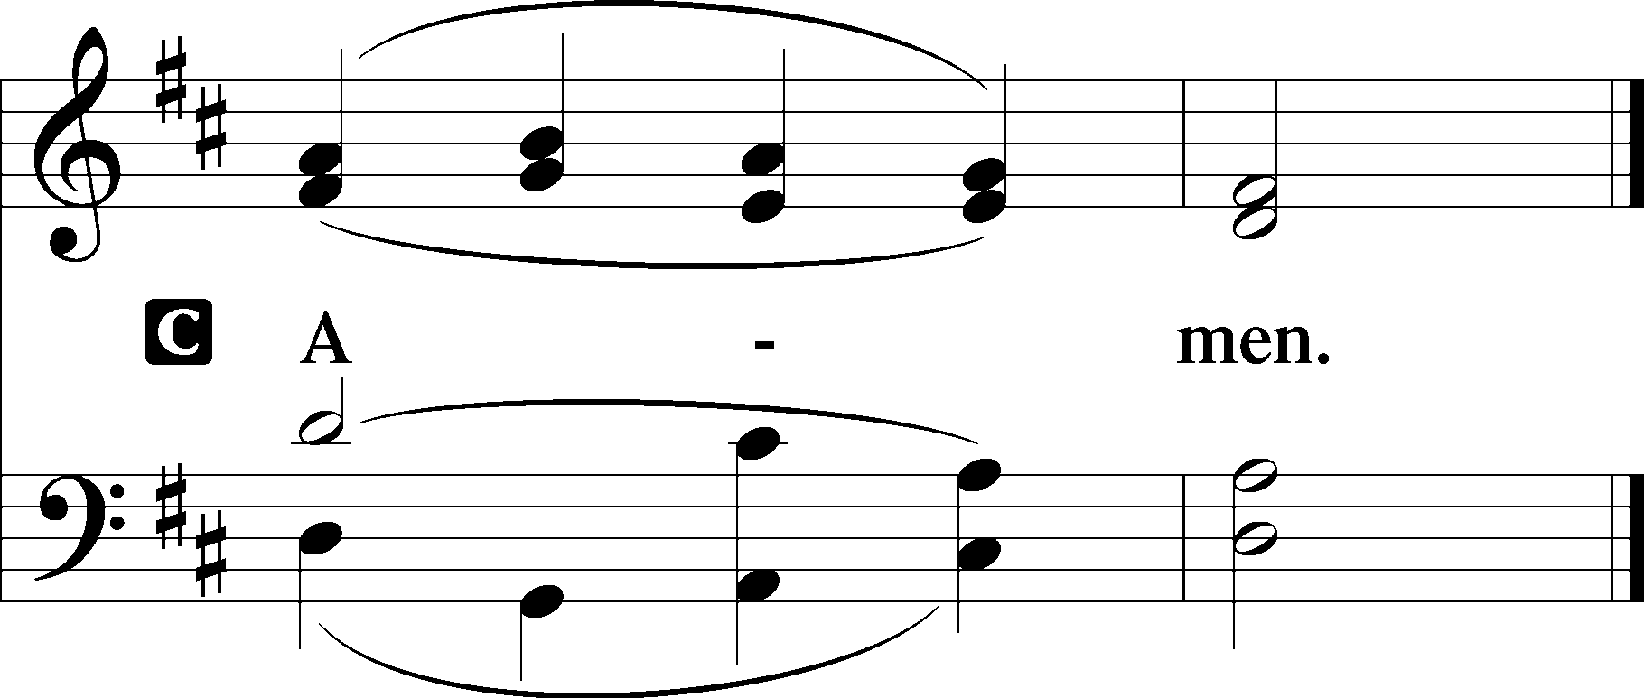
Salutation 2 Timothy 4:22
P The Lord be with you.
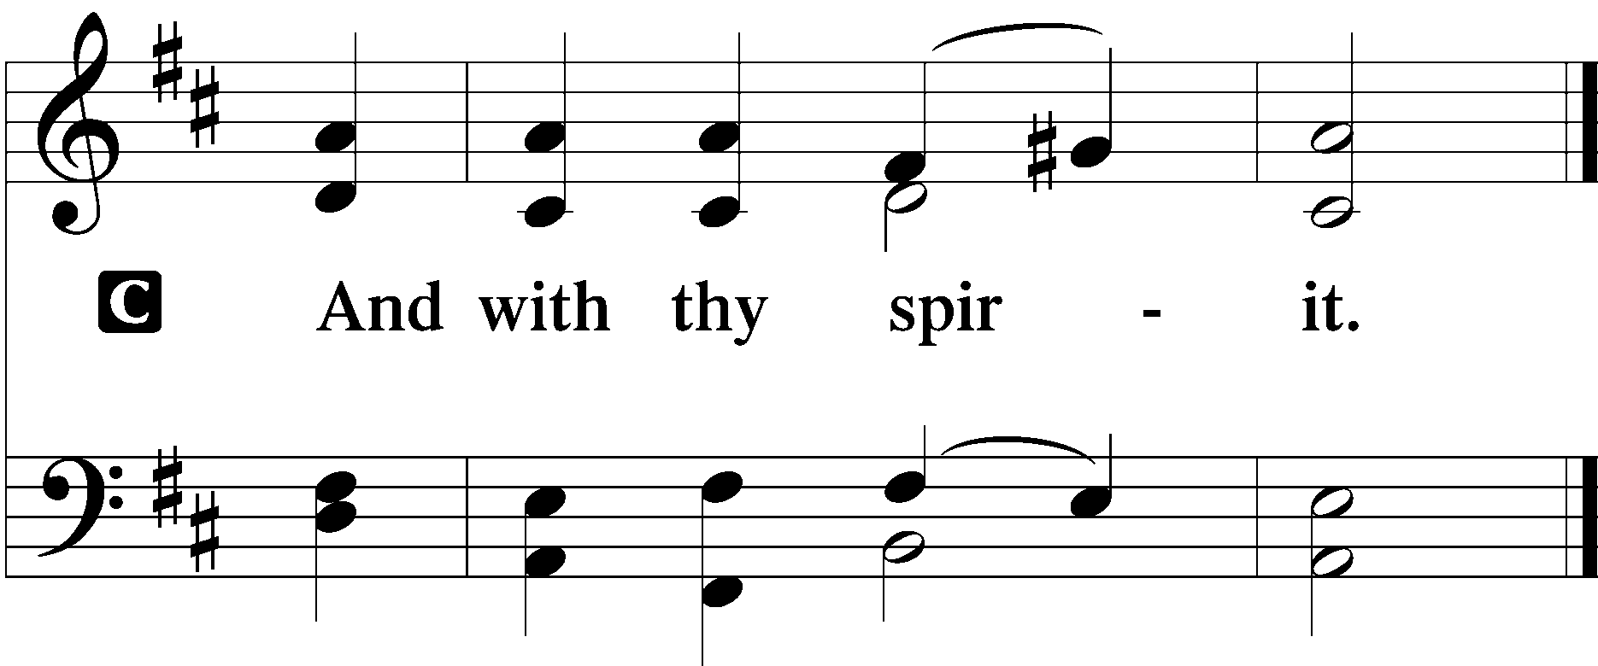
Benedicamus Psalm 103:1
A Bless we the Lord.
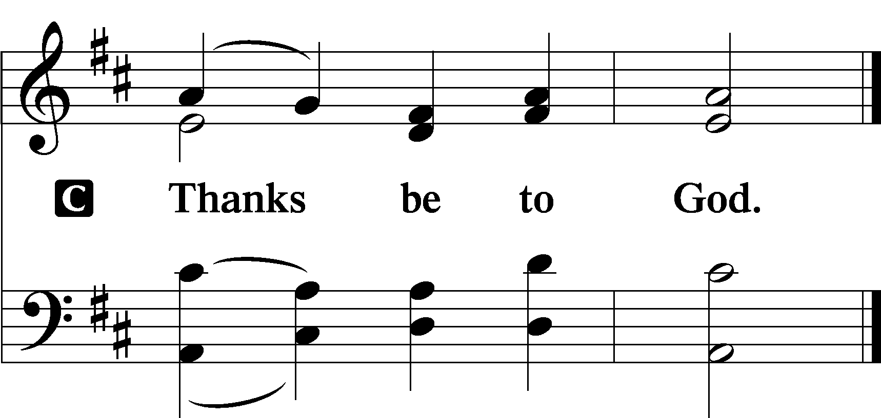

Benediction Numbers 6:24–26
P The Lord bless you and keep you.
The Lord make His face shine upon you and be gracious unto you.
The Lord lift up His countenance upon you and T give you peace.

Acknowledgments
Unless otherwise indicated, Scripture quotations are from the ESV® Bible (The Holy Bible, English Standard Version®), copyright © 2001 by Crossway, a publishing ministry of Good News Publishers. Used by permission. All rights reserved. Created by Lutheran Service Builder © 2022 Concordia Publishing House.

Announcements
Today
Voters will meet TODAY between services on Sun, Feb 20 to elect officers and board members whose terms begin on Mar 1, 2022 and to review year end financials and reports.

Deaconess Pamela (and husband Dennis) from Holy Cross Lutheran Church in Rocklin, CA will be visiting us TODAY to present on mission work in Kenya. (Presentation will be between services, after Voters meeting.)

Young Adults (18ish to 25ish) Bible Study will meet TODAY at 5:00 p.m. with dinner, hangout, and a study led by Levi. Location is Levi & Suzanne Nunnink’s home: 1416 Lonas Dr. Maryville, TN 37803

This week
*** Cards Creation *** is this Tues, Feb 22, at 1:00 p.m. at Praise
Choir this Wednesday at 5:30 p.m.

Youth Group this Wednesday at 7:00 p.m.
Ladies Bible Study Thurs at 10:00 a.m. at Praise (pericope study led by Barbara Morsch)
Men’s Lunch (weekly): Thurs. at 11:30 a.m. Location this week: Margaritas on 411

Next Sunday
Youth Catechesis meets next Sunday, Feb 27 after church and will end at 1:30 p.m.

The Transfiguration of our Lord (the final Sunday after Epiphany) is next Sunday, Feb 27. Ash Wednesday (the beginning of Lent) will be Mar 2. Wear white to match the colors of the day!

